This is the photo we will be starting with :
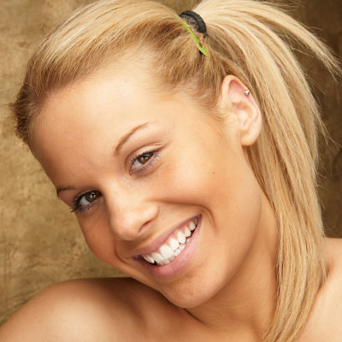
The first stage is to mask her hair out, to do this, press ‘q’ then select a suitable brush and paint over her hair – don’t worry if you go over the edges we will sort that out later :
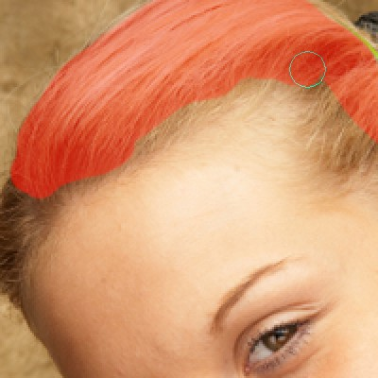
Once the hair is covered in the red overlay, press ‘q’ again which will put a selection around the area, then on the menu go to select > inverse and should have something like this :
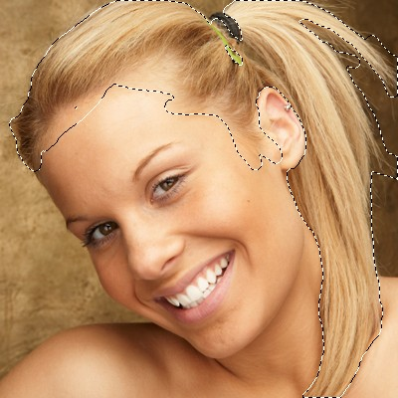
Create a new layer and then fill the area with the color of your choice, I have chosen to go with a dark red/brown :
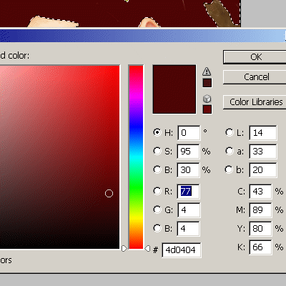
Now, right click on the hair layer and select blending options, change the blend mode to soft light :
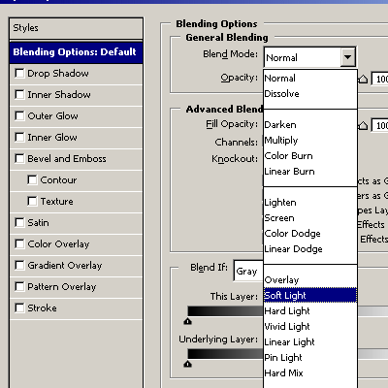
Thats looks better, but there will be some areas where you went over her hair line/ears etc. Select the eraser brush on a larger feathered size brush and start to clean up those bits :
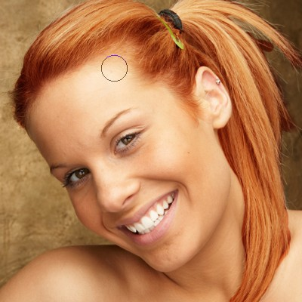
When you have it looking how you want, duplicate that layer to make the hair shade darker and again you will see some bits which need to be cleaned up with the eraser brush, choose an even larger feathered brush for this (size 65 or 100 for this image) and blend it in a little bit more :
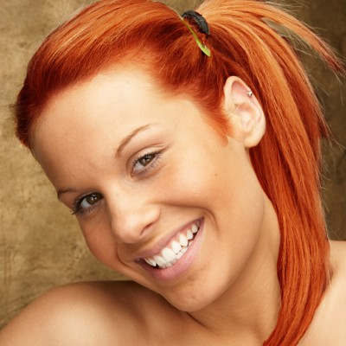
You can also switch between the two hair layers, slowing working on tidying it up so it looks natural – you can also delete bits on top of the hair and the strands to give the impression of blonde highlights. Play about with this untill you get the desired effect, here’s our finished image :
